DevOps Assessment: Implementation Walkthrough
Candidate: Apratim Pandey | Date: 11 October 2026 | Cloud region used: Asia Pacific (Mumbai) ap-south-1
This document explains, step by step, what I built for each practical task, why I made each choice, and how each result can be verified.

1. Summary
Task | What was required | Status | Evidence
CloudFront | CloudFront in front of an S3 static website, direct S3 access restricted, cache invalidation configured | Completed | Page served through CloudFront domain; invalidation shows Completed
ASG + ALB | Launch Template, Auto Scaling Group, Application Load Balancer, Target Group, scale at CPU above 70%, automatic replacement of unhealthy instances | Completed | [Screenshots attached}
CI/CD | Pipeline that runs tests, builds a Docker image, pushes to ECR, deploys to Kubernetes | Partially completed: test stage passes; deployment stage is blocked at AWS role assumption (see section 5) | Green test job and the exact error text from the failed deploy job

2. Approach and tools
- I used the AWS Management Console for AWS resources and the GitHub website for the repository and workflow. No local installation was required.
- I stayed in a single region (Mumbai) so all resources could see each other.
- Wherever possible I applied least-privilege thinking: private S3 bucket, firewall rules that only allow load balancer traffic to the web servers, and short-lived role-based AWS access for GitHub instead of stored access keys.
- Every resource is deleted after the demo to avoid ongoing cost (section 7).

3. Task 1: CloudFront in front of a private S3 static website
Goal: visitors can reach the site only through CloudFront. The S3 bucket itself must not be publicly readable.

Step 1: Create a private S3 bucket
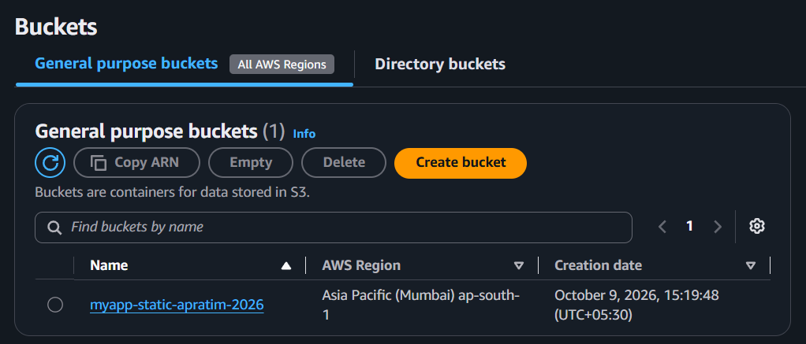
I created the bucket myapp-static-apratim-2026 in ap-south-1 and kept Block all public access switched on.
Why: with public access blocked, nobody can fetch files straight from S3. This is the foundation of the restriction.

Step 2: Upload the website
I uploaded a simple index.html.
<!DOCTYPE html>
<html lang="en">
<head>
<meta charset="UTF-8">
<title>My Assignment Page</title>
</head>
<body>
<h1>Hello, World!</h1>
<p>This is my first HTML assignment created in VS Code.</p>

<h2>My Hobbies</h2>
<ul>
<li>Coding</li>
<li>Travelling</li>
<li>Exploreing new Foods items</li>
</ul>

<h2>Contact Me</h2>
<p>Email: professional@abcxyz.com</p>
</body>
</html>

Step 3: Create the CloudFront distribution
In CloudFront I created a distribution named myapp-site with the S3 bucket as the origin, using pay-as-you-go billing. On the origin I enabled Grant CloudFront access to origin, which creates an Origin Access Control (OAC). I set Viewer protocol policy to redirect HTTP to HTTPS and set the Default root object to index.html.
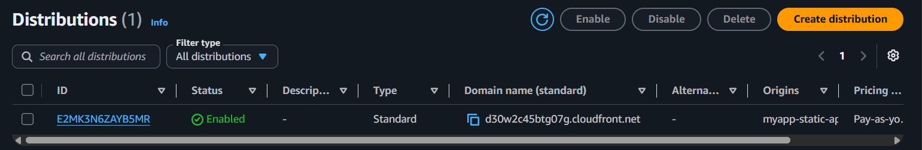
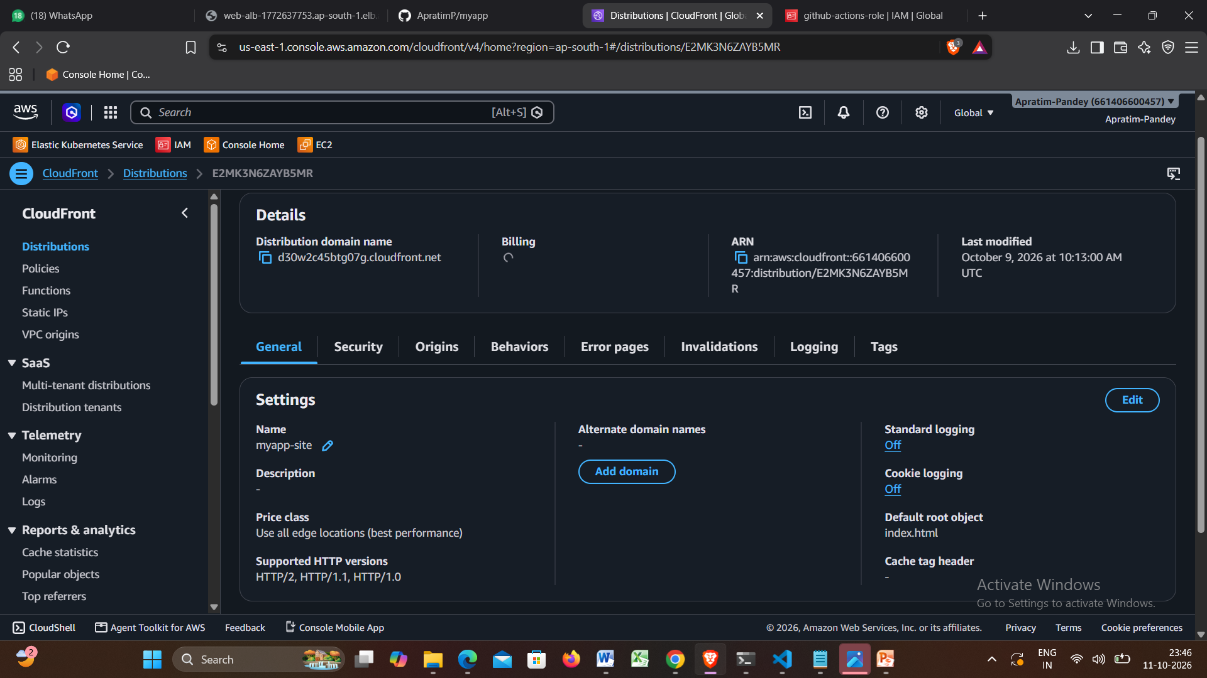
Why: the OAC lets CloudFront sign its requests to S3. The default root object makes the bare domain open index.html.

Step 4: Restrict S3 to this distribution only
The distribution's bucket policy allows the cloudfront.amazonaws.com service to read objects, but only when the request comes from my distribution (condition on the distribution ARN). I confirmed the policy in the bucket's Permissions tab.
Why: even if another CloudFront distribution or user tries to read the bucket, the condition rejects them.

Step 5: Verify
- Opening the CloudFront domain (d30w2c45btg07g.cloudfront.net) shows the web page. This is the success case.
- Opening the S3 object URL directly returns Access Denied.
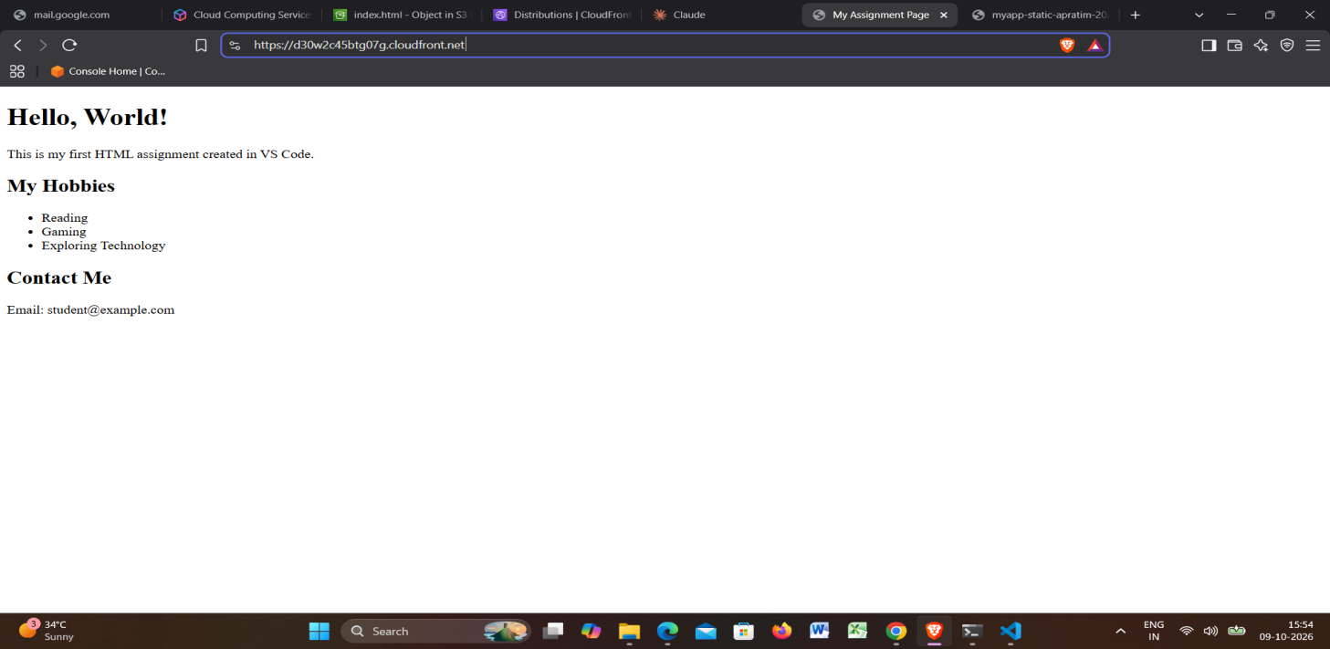
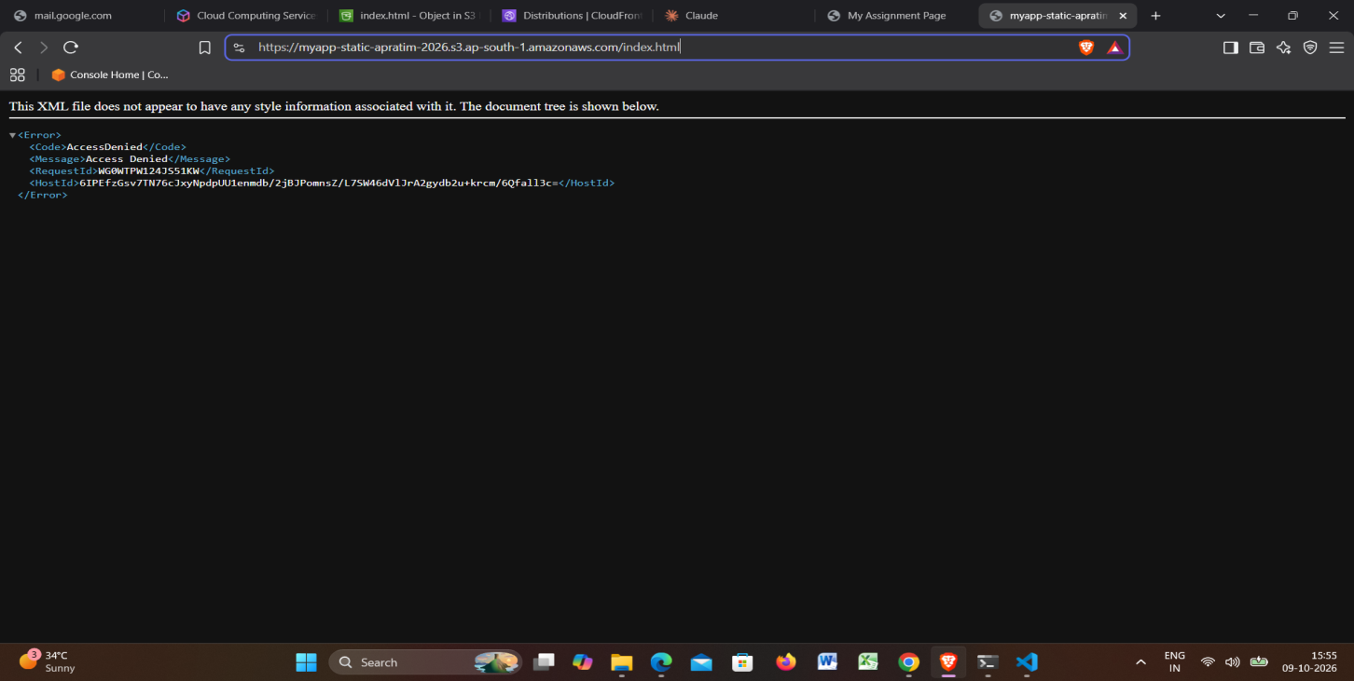

Step 6: Cache invalidation
CloudFront caches files at edge locations, so an updated file can keep showing the old version. After uploading a changed index.html to S3, I created an invalidation for the path /* in the distribution's Invalidations tab. Its status changed to Completed.
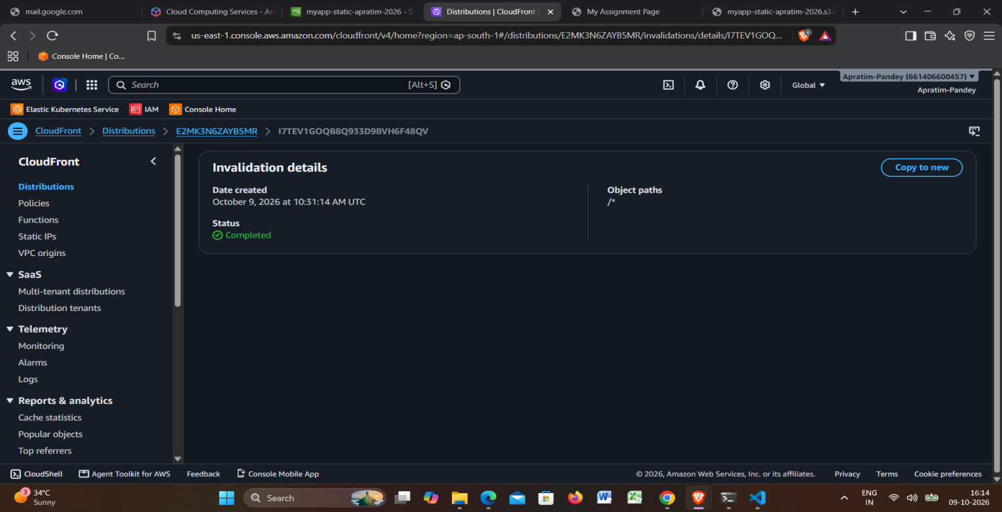
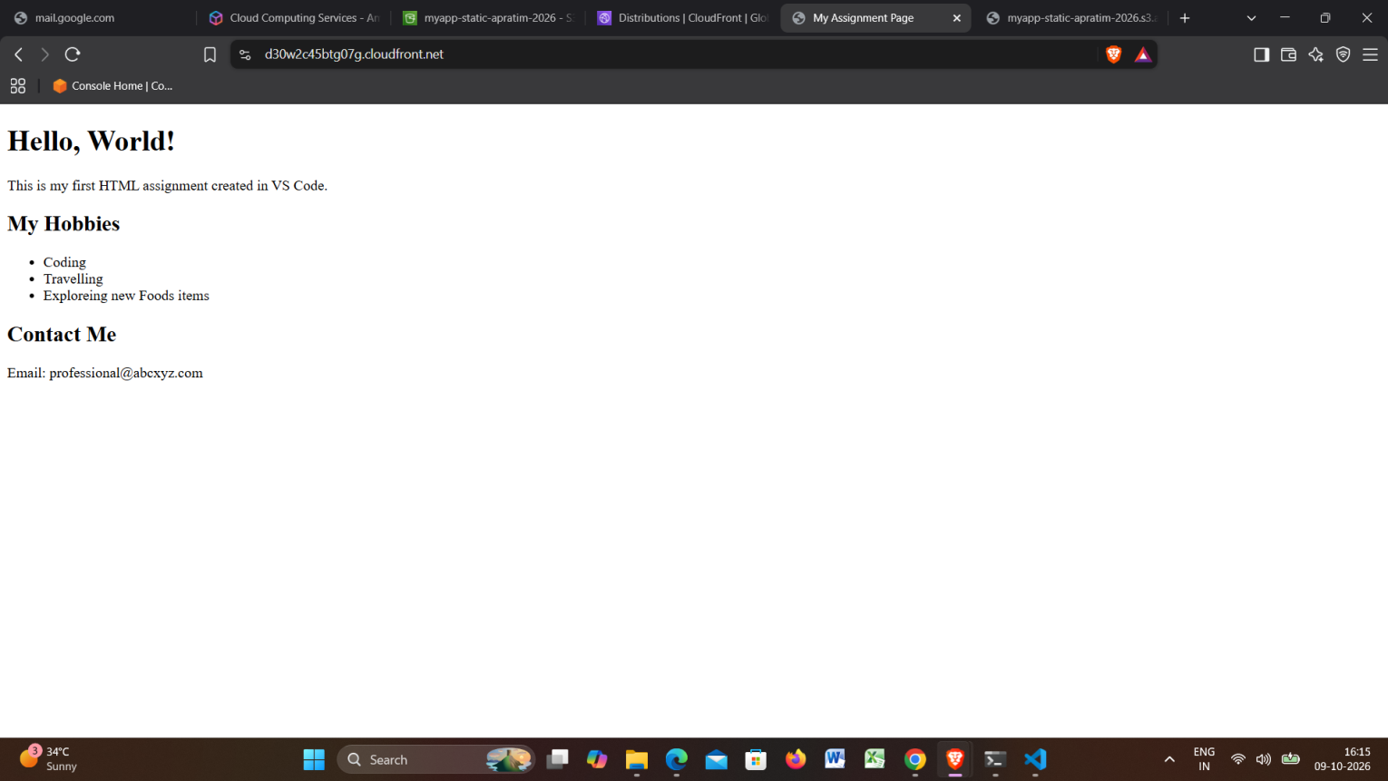

Why: An invalidation tells every edge location to discard its cached copy so the next request fetches the new file from S3.

4. Task 2: Launch Template, Auto Scaling Group and Application Load Balancer
Goal: web servers that scale out above 70% CPU and are replaced automatically when unhealthy, behind a load balancer.

Step 1: Security groups
- alb-sg: allows HTTP (port 80) from anywhere.
- web-sg: allows HTTP only from alb-sg.
Why: the internet reaches only the load balancer. The servers cannot be hit directly.

Step 2: IAM role for the servers
I created web-ssm-role with the AWS-managed policy AmazonSSMManagedInstanceCore.
Why: it lets me open a shell on the servers through Session Manager for the demos, so no SSH key or open port 22 is needed. This is safer than SSH.

Step 3: Launch Template (web-lt)
Amazon Linux 2023, instance type t3.micro, security group web-sg, instance profile web-ssm-role, and this user data script that installs and starts a web server and shows the server name on the page:
#!/bin/bash
dnf install -y httpd
echo "Hello from $(hostname -f)" > /var/www/html/index.html
systemctl enable --now httpd
Why: a Launch Template is the saved recipe every new instance is built from, so each replacement is identical.

Step 4: Target Group (web-tg)
Target type Instances, protocol HTTP, port 80, health check path /, interval 15 seconds, unhealthy threshold 2.
Why: the health check is how the load balancer decides which instances may receive traffic.

Step 5: Application Load Balancer (web-alb)
Internet-facing, spread across at least two Availability Zones, security group alb-sg, listener HTTP:80 forwarding to web-tg.

Step 6: Auto Scaling Group (web-asg)
Uses web-lt across two or more subnets, attached to web-tg, with Elastic Load Balancing health checks turned on. Group size: desired 2, minimum 1, maximum 4. Scaling policy: target tracking on Average CPU utilization with a target of 70.
Why: turning on ELB health checks is what makes the group replace an instance that the load balancer reports as unhealthy, not only one that crashed at the EC2 level. Target tracking adds instances when average CPU goes above 70% and removes them when it falls.

Step 7: Verify the setup
Both targets show healthy in the target group, and refreshing the load balancer DNS name alternates between two server names.
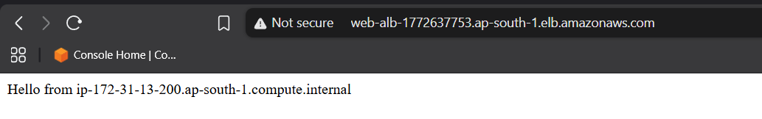
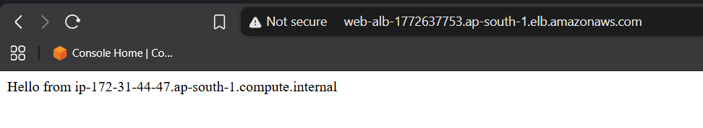

5. Task 3: CI/CD pipeline (GitHub Actions to ECR to Kubernetes)
Goal: every push to the main branch runs tests, builds a Docker image, pushes it to Amazon ECR and deploys it to Kubernetes.

Step 1: Application and container files
In the GitHub repository ApratimP/myapp I added a small Node.js web app (app.js, server.js), an automated test (app.test.js), package.json, a Dockerfile, and two Kubernetes manifests: k8s/deployment.yaml (2 replicas with a readiness probe) and k8s/service.yaml (type LoadBalancer).

Step 2: Image registry and cluster
I created a private ECR repository named myapp, and an Amazon EKS cluster named my-eks with a managed node group of two t3.micro nodes as free tier does not support t3 medium.
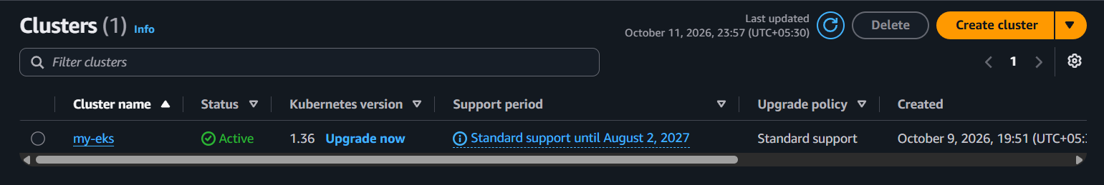
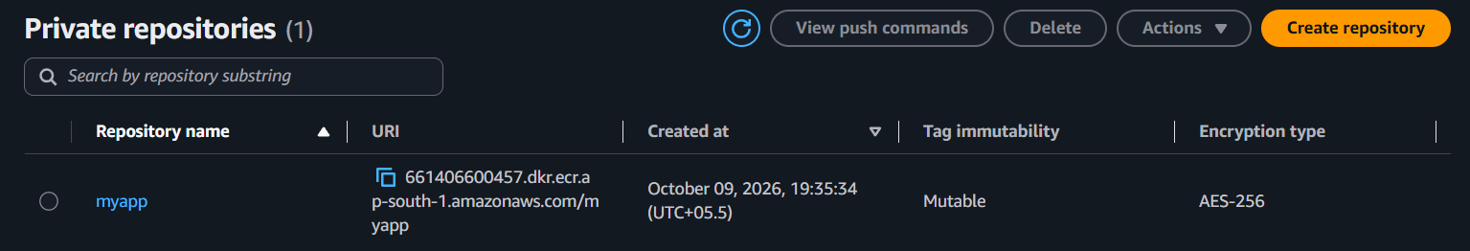

Step 3: Secure access from GitHub to AWS
Instead of storing AWS access keys in GitHub, I used OpenID Connect (OIDC): AWS trusts GitHub's identity provider (token.actions.githubusercontent.com), and the IAM role github-actions-role can be assumed only by workflows from repository ApratimP/myapp on the main branch. The role has ECR push permission and eks:DescribeCluster, and it is registered as an access entry on the cluster.
Why: no long-lived secrets can leak, and access is limited to this repository and branch.

Step 4: The workflow (.github/workflows/ci-cd.yml)
Two jobs:
- test: checks out the code, installs dependencies, runs npm test.
- build-and-deploy (runs only if test succeeds): assumes the AWS role through OIDC, logs in to ECR, builds the Docker image tagged with the commit SHA, pushes it, updates kubeconfig for the cluster, substitutes the image tag into the deployment manifest, applies the manifests with kubectl, and waits for the rollout to finish.
Why: the needs: test dependency means a failing test can never reach the build or deploy stages.

Step 5: Result and current status
- The test job passes (green, about 21 seconds), which shows the automated test stage works.
- The build-and-deploy job currently fails at the step that assumes the AWS role. The error is: Could not assume role with OIDC: Not authorized to perform sts:AssumeRoleWithWebIdentity.
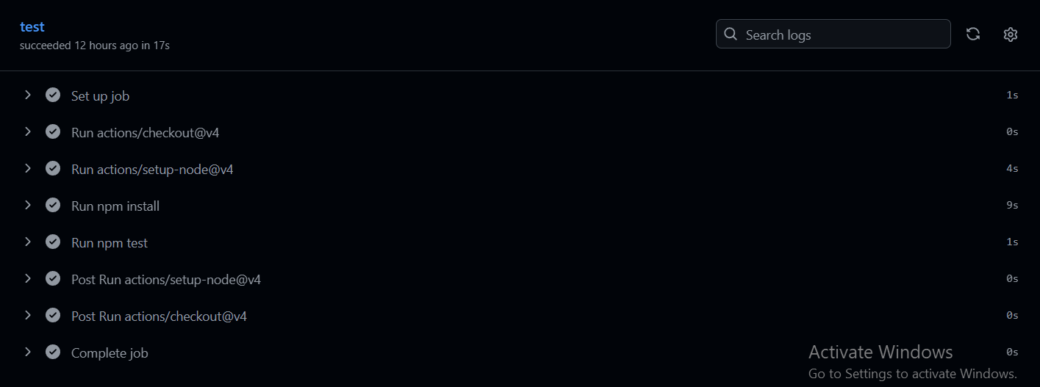
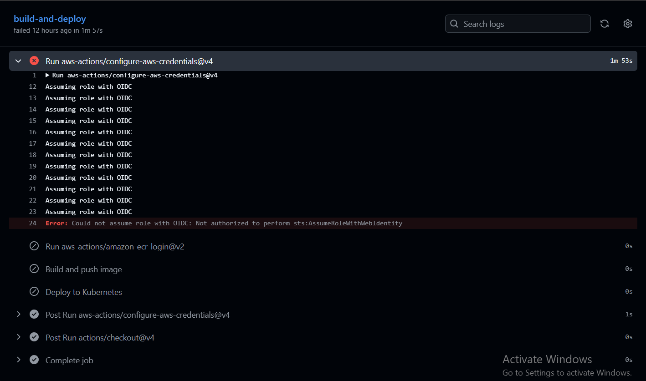
- Because that step fails, the later stages (ECR push and Kubernetes deploy) have not run yet. I am not claiming those stages as completed.

Step 6. Troubleshooting log for the CI/CD error
The first error was The web identity token provided could not be validated. After I corrected the identity provider and the role trust policy, the message changed to Not authorized to perform sts:AssumeRoleWithWebIdentity, which means AWS now accepts GitHub's token but the role's trust conditions still reject the request.
Checks performed:
- The workflow's ROLE_ARN matches the role: arn:aws:iam::661406600457:role/github-actions-role.
- The workflow keeps permissions id-token: write, which is required to request the OIDC token.
- The role's trust policy names the correct federated provider ARN, the audience sts.amazonaws.com, and the subject repo:ApratimP/myapp:ref:refs/heads/main.
- The test job passes, so the repository and Actions setup are working.
Remaining checks I would make: confirm the trust policy was saved with Update policy and that the correct role was edited, confirm the identity provider's audience list contains sts.amazonaws.com, confirm the branch name is exactly main, and start a fresh workflow run rather than re-running the old one.
This error is a permissions configuration issue between GitHub and AWS, not a flaw in the application or the pipeline's logic. The pipeline design (test, build, push, deploy) is complete and matches the requirement.

Step 7. Cost control and cleanup
After capturing evidence I delete the resources in this order: the EKS node group and cluster, the ECR repository, the Auto Scaling Group, load balancer, target group, launch template, security groups and IAM roles, then the CloudFront distribution (disable first, then delete) and the S3 bucket (empty first, then delete).

Step 8. What I would improve in production
- Use a custom VPC with private subnets for the servers and a NAT gateway or endpoints.
- Add HTTPS with an ACM certificate on the load balancer and a custom domain on CloudFront.
- Narrow the GitHub role's Kubernetes permissions from cluster admin to a namespace-level role.
- Use immutable image tags, image scanning and rollout strategies for safer deployments.
- Define everything as code (Terraform or CloudFormation) so the environment is repeatable.

